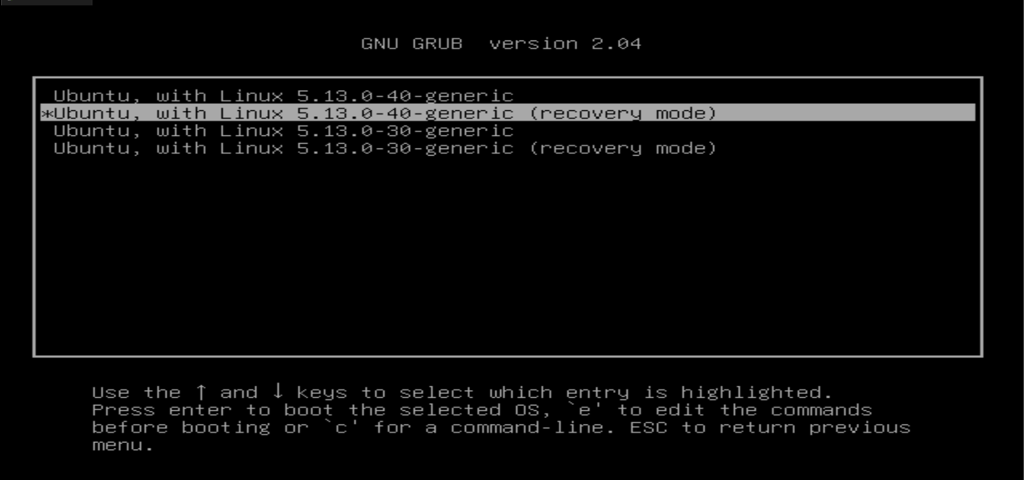

GNU GRUB

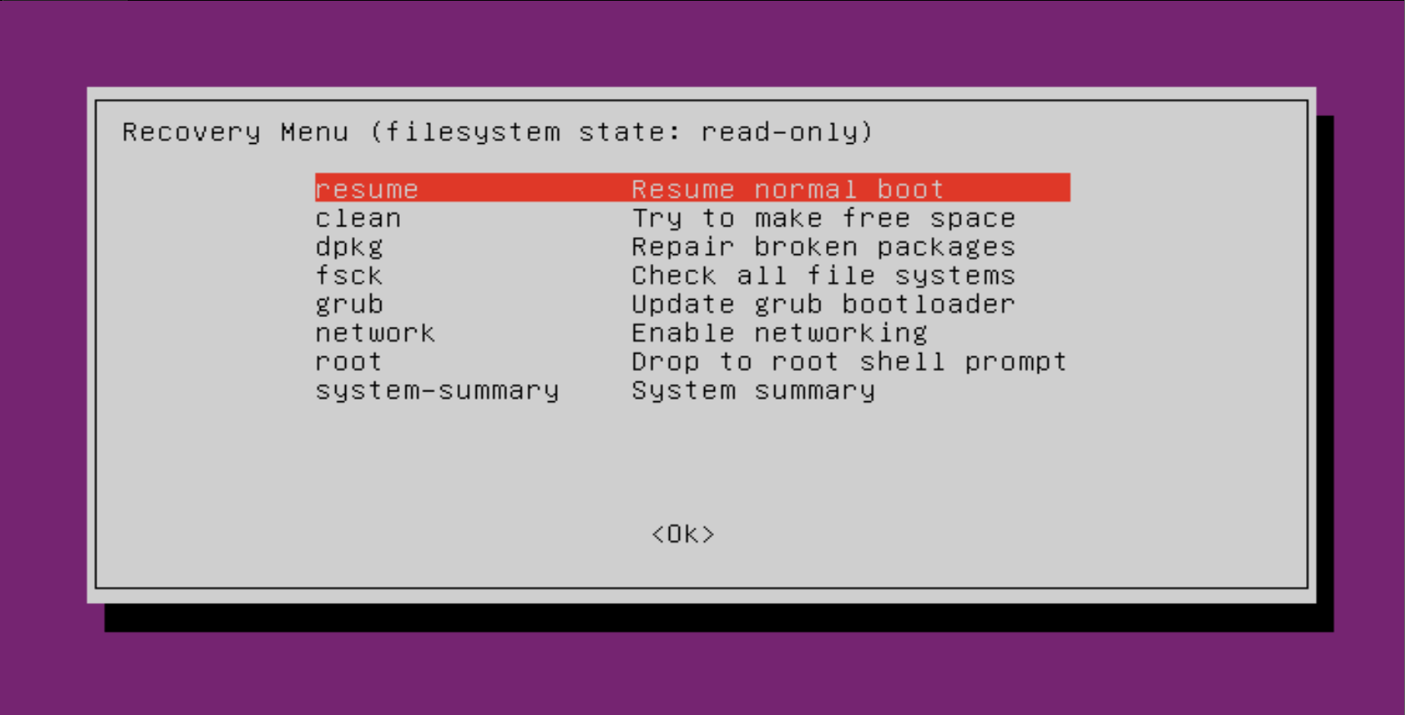

Recovery Menu

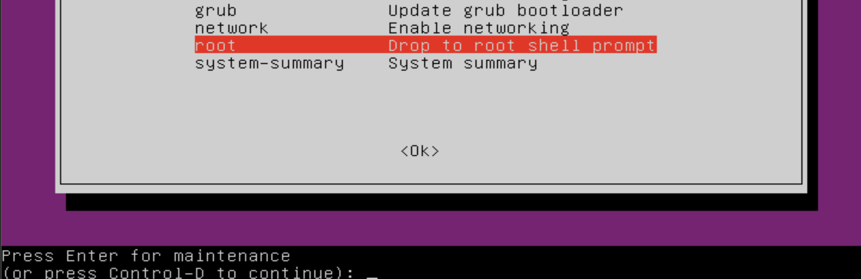

Root Shell

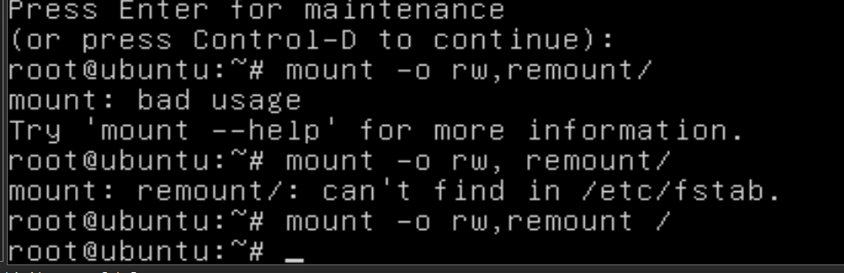

Mount -o rw,remount /

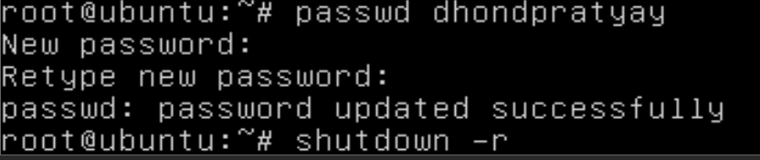

Changing password